2.creating and manipulating database table using SQLDDL commands
Create database science;
use science;
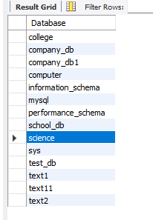
show databases;

Create a table
create table science(emp_id int, emp_name varchar(100), city varchar(50));
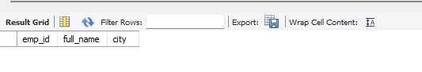
select*from employee;

After a table-Add column
alter table employees add department varchar(50);
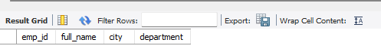
select*from employees;

Rename column
alter table employees rename column emp_name to full_name;
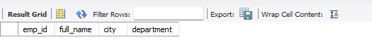
select*from employees;

Truncate table
truncate table employees;
select*from employees;
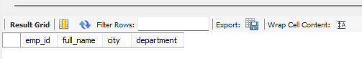

Drop table
drop table employees;
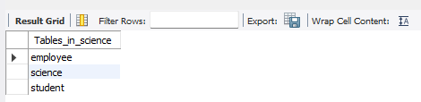
show tables;

